**2D Fun Time**

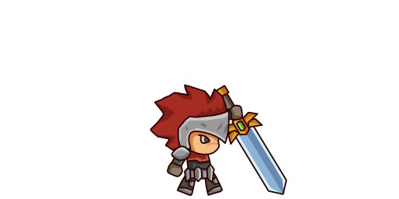

**The water knight**

**2D fun Time**

The Cove Games

Prepared by: Josh Cove last update: 10/18/2018

**Gameplay**

There will be no story simply run and jump. The game will also include at least one collectable. The player will control Chuck from a 2d side scroller view. The player will run on water avoiding enemy sharks.

**Heroes**

Chuck – He can run for a very long time. Recently he also learned to jump.

**Genre**

2D side scroller, infinite runner.

**Platform**

This game will target pc only.

**Collectables**

The player will need to collect fish.

**Controls**

Movement – auto run.

Jump – Spacebar/Left mouse button.

Attack/collect-- Right mouse click/key-F.

**Update Log**